Registration Form
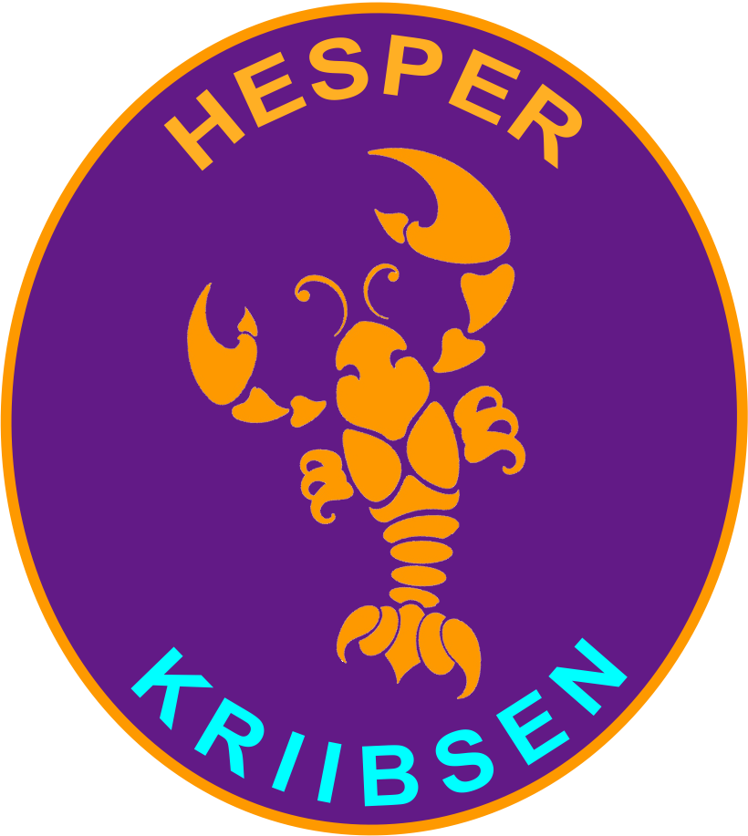
Hesper Kriibsen
affiliate of FNEL a.s.b.l.
9a, rue Albert Bousser • L-5894 Alzingen
cheffen@kriibsen.lu
I .......................................................................................................................................
Surname / Name of new member
.......................................................................................................................................................
Nr, street
.......................................................................................................................................................
Postal code, City
.......................................................................................................................................................
Telephone GSM Telephone office e-mail

................................................................. …………………………………… M / F / A
Date of birth / social Security Nationality Gender
I engage as :
Beaver Cub Scout Explorer Rover Tembo Leader
(5-7 yrs) (8-10 yrs) (11-13 yrs) (14-15(16) yrs) (16(17)-20 yrs) (from 21 yrs on) (from 16 yrs on)
In the local group: Hesper Kriibsen

Parent/Guardian Name
Name, Address:
Family relationship:
E-mail: tel. / GSM :

Name, Adress :
Family relationship:
E-mail: tel. / GSM :

The undersigned …………………................................................………………..……………
Surname, Name

- confirms that the member adheres to the statutes of the group and hereby those of the FNEL asbl, as well as to all related regulations.
- Authorizes the group and FNEL to use the data provided by this form for their computer files (internal group and federation use only)
- gives his consent as to the fact the registration to a group activity, or a FNEL activity is done via SMS/e-mail where a physical signature of the attendee or its legal representative is not necessary; the sole dispatch of an SMS or an e-mail is sufficient.
- has knowledge of the data processing policy of the FNEL, which is indicated on the FNEL website, and gives consent that the personal data of the signee or its legal representative is used in the frame of the purpose described thereon.
- agrees that the photos taken during the Scouting events and on which he/she may appear, can be published by the group and FNEL the group in the press and for any other non-commercial purpose related to the communication of the federation or Scouts groups.

.............................................................................

Date and Signature (of the legal representative for minors)

